Recommendations for the Chartering Officer:
- Please review slide 31. Either remove it before the induction or fill in the slide with after-induction event information.
- Prepare a one- to two-minute personal testimonial for slide 18.
- Seat candidates in alphabetical order at the front of the room. Call their names in alphabetical order (slide 16).

1 | 
2 |  | Good morning/afternoon/evening, my name is  [Name and Title]. I would like to welcome you all to the Honor Society of Nursing, Sigma Theta Tau International [Chapter Name] Chapter chartering and induction ceremony. I am delighted you are here to celebrate this special occasion with us.
3 | 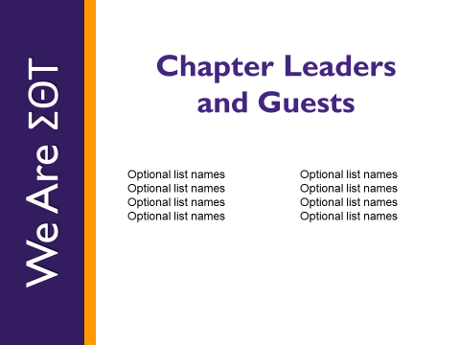 | I would like to take a moment to introduce our chapter leadership and other invited guests who are with us this morning/afternoon/evening.  [Introduce those in attendance by name and title.]
4 |  | Let’s begin our induction.  For more than 90 years, Sigma Theta Tau International — or STTI — has been recognizing and celebrating nursing excellence in scholarship, leadership, and service.  [Chapter Name] chapter at [University] is proud to charter as a member this global community of nursing.
5 | 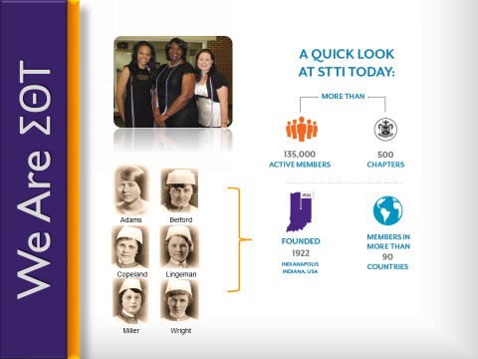 | The Honor Society was founded in 1922 [click mouse or press enter] [pulse each quadrant] by six nursing students at Indiana University [in the United States of America]. From those six founding members, our organization has grown to more than 135,000 active members [click mouse or press enter] [pulse] in more than 90 countries around the world. [click mouse or press enter] [pulse] Our organization has approximately 500 chapters worldwide. [click mouse or press enter] [pulse] We are excited and filled with pride to welcome these new inductees into our membership here today.
6 | 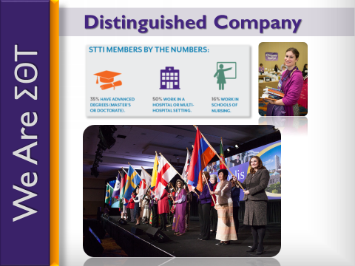 | [Address remarks directly to inductees]  You are among a distinguished group of nurses [click mouse or press enter] — students and professionals — who have met or exceeded the rigorous standards required to receive an invitation to join our chapter, and you truly deserve our congratulations. [Presider leads applause]
7 |  | The leadership and scholarship that you have displayed represent the essence of the society.  You are Sigma Theta Tau; We are Sigma Theta Tau.
8 |   Version 1: video embedded  Version 2: play video through separate program/device | [Direct audience attention to video screen]  [Move mouse over the lower third of the screen. The video play button will appear. Click play and move the mouse cursor off of the video.]  [Video plays]
9 | 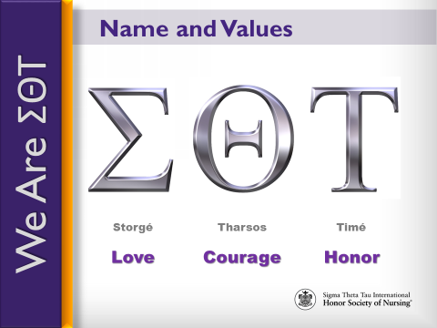 | Sigma. [click mouse or press enter]  Theta. [click mouse or press enter]  Tau. [click mouse or press enter]  Taken from the Greek words meaning Love [click mouse or press enter], Courage [click mouse or press enter], and Honor [click mouse or press enter], these are the Greek letters chosen by our founders to be the Honor Society’s name, as they believed them to be the enduring values that are the root of the nursing profession.
10 | 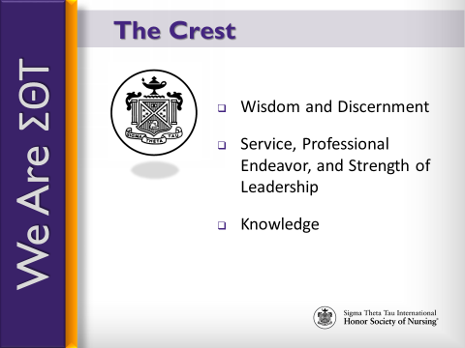 | Our crest, which adorns your membership certificate, symbolizes these enduring values, reminding us of our commitment to:  - [click mouse or press enter] Wisdom and discernment, as represented by the eye;  - [click mouse or press enter] Service, professional endeavor, and strength of leadership, as represented by the pillars of stone at the right and left; and  - [click mouse or press enter] Knowledge, as represented by the lamp.
11 | 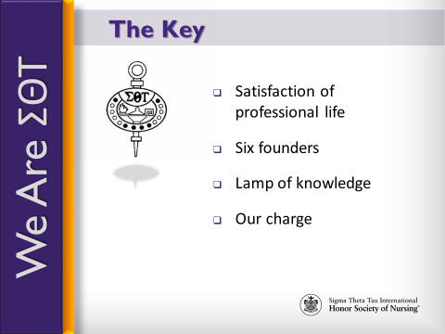 | Our key, embedded in the membership pin, reminds us of our charge to uphold love, courage, and honor and is a symbol of scholarship.  - [click mouse or press enter] The cup denotes the satisfaction of professional life;  - [click mouse or press enter] The circle with its six stars represents our six founders;  - [click mouse or press enter] The lamp is the lamp of knowledge; and  - [click mouse or press enter] The letters in black represent our charge.  As you wear your key, remember that it symbolizes your commitment to nursing excellence; wear it proudly.
12 | 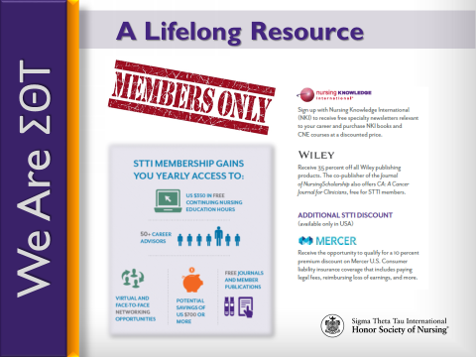 | The purpose of this ceremony is not only to honor you as a new member and celebrate your successes, but it also serves as our pledge to you to support you throughout your nursing career and to be a lifelong resource for you.
13 | 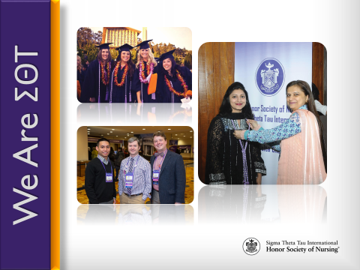 | Your induction is not the end – the culmination of your scholarly or professional achievements; instead, your induction signifies the beginning of your membership journey – the start of your involvement within a global network of peers and mentors who are here to guide and support you wherever your nursing career may take you.
14 | 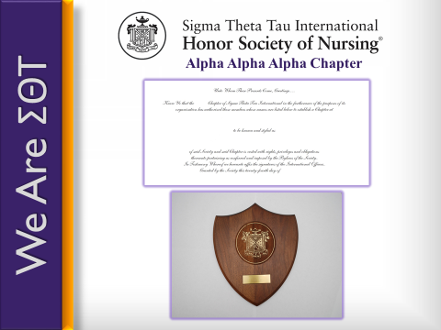 | [Presentation and Response]  Chartering Officer:  Your nursing honor society at (college/university name) has demonstrated its commitment to nursing excellence, met the requirements for establishing a chapter, and was approved to become a STTI chapter.  Will the following nursing honor society representatives please come forward:  (name), honor society president  (name), honor society (officer position)  As representatives of your nursing honor society, do you know and accept the purposes of the Honor Society of Nursing, Sigma Theta Tau International?  Honor Society Representative:  Yes, we the members of this nursing honor society have studied the purposes of the Honor Society of Nursing, Sigma Theta Tau International, and we accept them as the model for our own endeavors.  Chartering Officer:  On the recommendation of the Honor Society of Nursing, Sigma Theta Tau International Board of Directors, and by the power vested in me as the chartering officer, I am pleased to announce your chapter will be known as (Greek name) Chapter, chapter number (fill in chapter number) of the honor society.  <<Pause for applause>>  First, I present to you a replica of the top portion of the charter. Following this ceremony, your chapter will receive its official charter with charter members’ names inscribed.  Second, I present your chapter’s coat-of-arms plaque, which symbolizes the ideals of STTI and is inscribed with your chapter’s name and chartering date. Your chapter may choose to display the charter and coat-of-arms as a symbol of its continued commitment to nursing excellence and the honor society’s purposes.  Honor Society President:  On behalf of the prospective members, I am honored to accept this charter and coat-of-arms plaque for the (Greek name) Chapter at College/University. We are proud to become a chapter and pledge our commitment to nursing excellence and STTI’s purposes.  <<Pause for applause>>  <<Representatives may return to their seats>>  [Congratulations]  Chartering Officer:  Will (name), (position title—dean or director), please come forward and recognize those persons wishing to congratulate the Chapter for receipt of its charter and coat-of-arms.  <<Dean/Director should present a congratulations message from the nursing school or college/university. Dean/Director should also allow brief congratulatory messages from others. Dean/Director should then return to his/her seat.>>  Chartering Officer:  Thank you, (dean/director’s name). Please join me in congratulating this new chapter of the Honor Society of Nursing, Sigma Theta Tau International.  <<Pause for applause>>  At this time, we will receive into membership these outstanding new members. Will all of the candidates please rise?  [Pause]
15 | 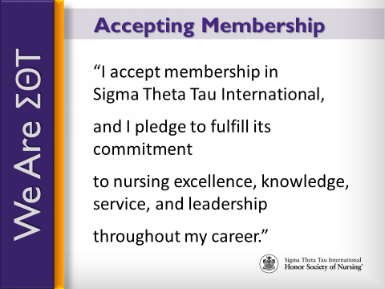 | Please accept the privileges and responsibilities of membership in the Honor Society of Nursing, Sigma Theta Tau International by repeating after me.  [click mouse or press enter]  I accept membership in Sigma Theta Tau International  [pause]  [click mouse or press enter]  and I pledge to fulfill its commitment  [pause]  [click mouse or press enter]  to nursing excellence, knowledge, service, and leadership  [pause]  [click mouse or press enter]  throughout my career.  Inductees, please be seated.
16 | 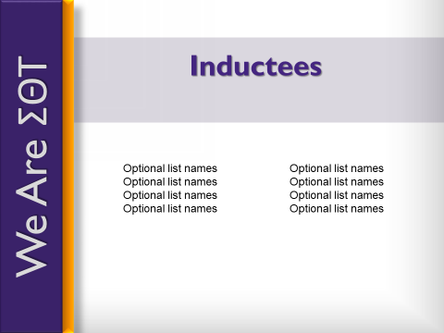 | << Chartering officer should now join other chapter leaders on the stage to shake hands with each new inductees as they come on stage to receive their new member materials. Only those nurses who are new members to STTI will receive a membership card, certificate and materials.  Chapter president recognize any deans/heads of school of the new school(s) to be added to the chapter first. These people should be called up first to receive the new member materials. If these people are already members of STTI, the chartering officer does not need to call these people to the stage.>>  Chapter President:  Helping us congratulate and recognize __________________ (chapter’s name) new members are: (introduce people on stage)  _________________ (name) ____________________ (title)  _________________ (name) ____________________ (title)  _________________ (name) ____________________ (title)  _________________ (name) _____________________ (title)  New members, please come forward when your name is called to receive your certificate and sign your name in the [Chapter Name] record of membership.  [Insert candidates’ names here]  [President will call each candidate forward.  In a line:  - The chartering officer will present certificate to and shake hands with each candidate.  - Chapter officers will:  - Pin purple ribbons on candidates  - Distribute other membership materials  - Distribute flowers (optional)  - Assist with the Signature Book]  Optional: Duplicate slide to add a slide a slide for absent inductees. Add “In Abstentia” to the title and add names of paid members who could not attend the ceremony.
17 | 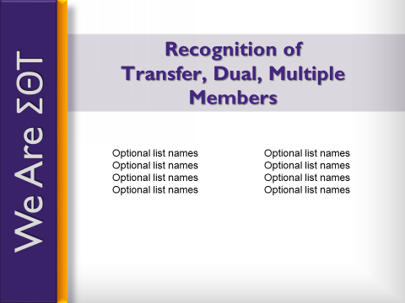 | President:  I would like to take a moment to recognize STTI members who have transferred to this new chapter or have become a dual or multiple member. Along with our newly inducted, these members will also be considered chartering members of ______ (name of chapter). Please stand and be recognized.
18 |  | Chartering officer:  Please help me congratulate these Sigma Theta Tau International and (name of chapter) members with our applause.  [Presider leads applause]  Now that you are official members of STTI, the opportunities to become involved, to grow and develop as leaders, and to contribute to the nursing profession are virtually endless. Personally, I have enjoyed being actively involved by [insert personal testimonial].
19 |  | Chartering Officer:  Leading you as members of the Chapter at the local level will be an elected group of officers. The following persons have been elected as the first group of officers for this chapter. As your names are called, please come forward:  President  President-Elect (optional)  Vice President  Secretary  Treasurer  Counselor  As set forth in the chapter’s bylaws, the duties of the officers are as follow:  - The president, as executive officer, administers all business of the chapter and serves as chief representative of the chapter at inter-chapter activities and as an ex-officio member of all committees except the Leadership Succession Committee.  - The president-elect assists the president in providing leadership for this chapter and succeeds into the presidency.  - The vice president performs the duties of the president in the president’s absence.  - The secretary prepares and distributes meeting minutes and correspondence.  - The treasurer is the custodian of the chapter’s funds and proposes a budget to the board of directors.  - The counselor oversees the membership eligibility process.  If your duties are fully understood, please answer “yes.”  <<Chapter officers answer “yes”>>
20 | 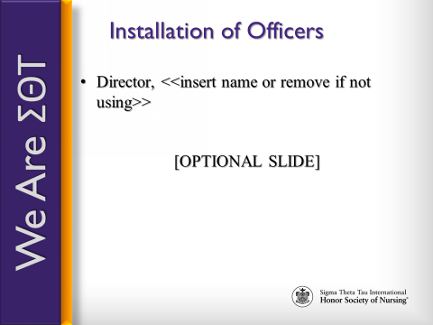 | <<The chapter may or may not have individuals elected as directors. If there are no elected directors, delete slide 19 >>  Will the member (s) elected as director(s) please come forward.  Director  Director  The director(s) facilitates the goals and purposes of the chapter through service on the board of directors.  If your duties are fully understood, please answer “yes.”  <<Director(s) answers “yes”>>
21 | 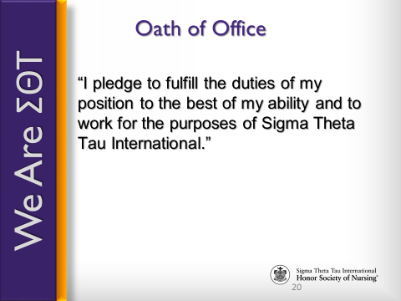 | <<For the following pledge, chartering officer should break the pledge into sections. Even though the pledge is on the Power Point presentation, chartering officer should have people repeat only a small portion at a time.>>  Will the board of directors (officers and directors), elected by the members, please repeat after me, in unison:  I pledge to fulfill the duties of my position  <<pause for repeat>>  to the best of my ability  <<pause to repeat>>  and to work for the purposes of Sigma Theta Tau International  <<stop to repeat>>.  I now recognize , president of Chapter.
22 | 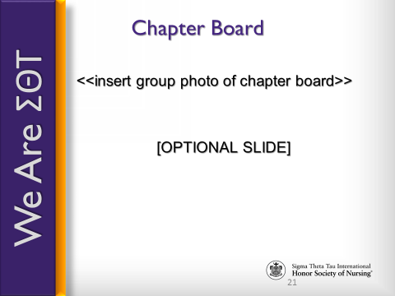 | Chapter President:  We, the board of directors, appreciate the confidence our members have placed in us, and we realize we have an obligation to serve the interests of our membership, our chapter, and the honor society. We look forward to our work in promoting nursing excellence and the honor society’s purposes.  <<Pause for applause>>  <<Board of directors may return to their seats>>
23 |  | Each of you will experience membership in your own way. In fact, STTI membership is an experience that is yours to design. I hope you will make use of the many opportunities that membership has to offer. Not only do you have the opportunity to be involved locally, but there are opportunities to participate in this global organization on a regional and international level as well.
24 | 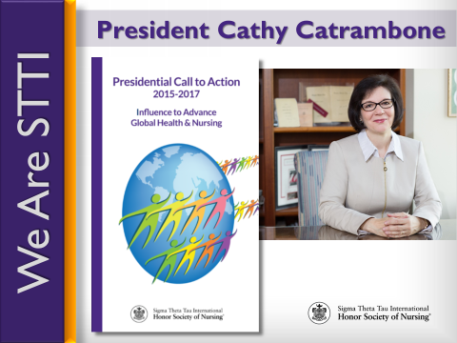 | Each biennium, STTI installs a new president at the international level. This biennium, we proudly installed Dr. Cathy Catrambone and introduced her as the 30th president of Sigma Theta Tau International.  [click mouse or press enter] Each president presents a Call to Action to help guide members and chapters as we strive to fulfill our mission. President Catrambone’s call asks us to Influence to Advance Global Health and Nursing through advocacy, policy, lifelong learning, and philanthropy.
25 |  | Advocacy is the act or process of pleading for, supporting, or recommending a cause or course of action. As a member, you can engage in advocacy dialogue, participate on interprofessional teams, or serve in elected leadership positions.
26 |  | President Catrambone also challenges us to advance through policy. Engage in the policy process. Develop relationships with administrators, the community, and other stakeholders. Leverage your networks and social media to share positive messages about STTI and the profession of nursing.
27 | 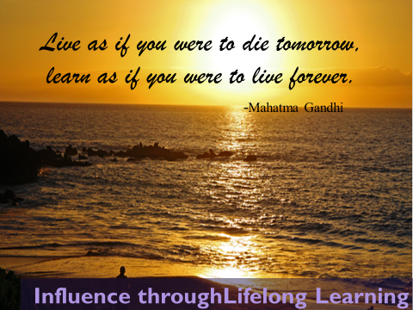 | Advance through lifelong learning. This component of President Catrambone’s charge urges each of us to engage in lifelong learning by pursuing advanced education and certifications, and by taking advantage of STTI knowledge products and services.
28 |  | The last charge that President Catrambone presents to us is one of philanthropy, which means giving of your time and talent in addition to monetary support. Consider performing 90 minutes of service in honor of STTI Founders Day on 5 October each year. Volunteer. Support STTI’s Future, Leadership, and Research funds, and advocate for the STTI mission.
29 |  | With that, I want to take a moment to recognize and thank the friends and family who are here to celebrate this special occasion with us. It is because of your love and support that these new members were able to reach this level of success, and you should take pride in the role you have played.
30 |  | As we conclude our ceremony, I want to once again congratulate and welcome our newest members of Sigma Theta Tau International.  [Lead applause]  Thank you for attending. Have a wonderful day/evening.
31 |  | Please join us for refreshments/dinner/a celebratory reception with our new members.

