Recommendations for Induction Presider:
- Please review slide 31. Either remove it before the induction or fill in the slide with after-induction event information.
- Prepare a one- to two-minute personal testimonial for slide 18.
- Seat candidates in alphabetical order at the front of the room.

1 |  | Chartering Officer:  Good morning/afternoon/evening, my name is  [Name and Title]. I would like to welcome you all to the Honor Society of Nursing, Sigma Theta Tau International [Chapter Name] Chapter Chartering and induction ceremony. I am delighted you are here to celebrate this special occasion with us.
2 | 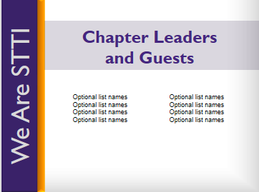 | I would like to take a moment to introduce our chapter leaders who will be installed today and honored guests who are here with us this morning/afternoon/evening.  [Introduce those in attendance by name and title.]
3 |  | Let’s begin our chapter chartering ceremony and induction.  For more than 90 years, Sigma Theta Tau International — or STTI — has been recognizing and celebrating nursing and midwifery excellence in scholarship, leadership, and service.
4 | 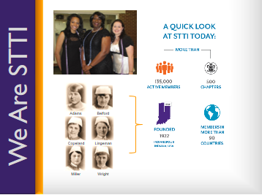 | The Honor Society was founded in 1922 by six nursing students at Indiana University [in the United States of America]. From those six founding members, our organization has grown to more than 135,000 active members in over 90 countries around the world. Our organization has more than 500 chapters worldwide.  STTI also collaborates with several global organizations to improve the health of the world’s people, including representation at the United Nations. This offers members the opportunity to extend their reach outside of their own communities.  We are excited and filled with pride to welcome our newest chapter and inductees here today into our diverse and global membership.
5 | 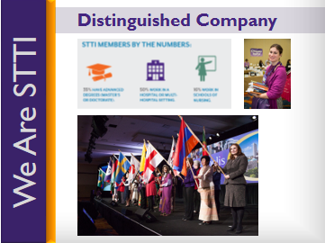 | [Address remarks directly to inductees]  STTI members are leaders at all levels of the healthcare industry. STTI only extends membership to students in baccalaureate or graduate level programs who have demonstrated superior academic achievements, academic integrity, and professional leadership potential and to nurse leader candidates exhibiting exceptional achievements in nursing. Our membership includes top-notch nursing and midwifery executives, clinicians, educators, researchers, policymakers, entrepreneurs, and others.  You are among this distinguished group of nurses — students and professionals — who have met or exceeded the rigorous standards required to receive an invitation to join STTI, and you truly deserve our congratulations.  [Presider leads applause]
6 |  | The leadership and scholarship that you have displayed represent the essence of the society.  You are Sigma Theta Tau; We are Sigma Theta Tau.
7 | 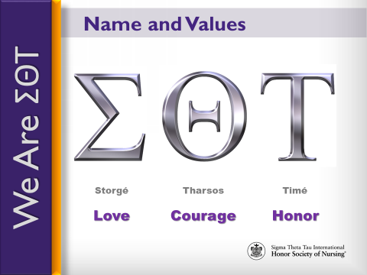 | Sigma.  Theta.  Tau.  Taken from the Greek words meaning Love, Courage, and Honor, these are the Greek letters chosen by our founders to be the Honor Society’s name, as they believed them to be the enduring values that are the root of the nursing profession.
8 | 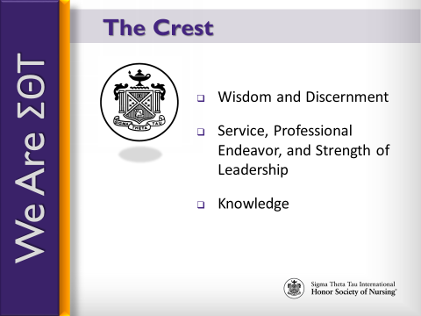 | Our crest, which adorns your membership certificate, symbolizes these enduring values, reminding us of our commitment to:  - Wisdom and discernment, as represented by the eye;  - Service, professional endeavor, and strength of leadership, as represented by the pillars of stone at the right and left; and  - Knowledge, as represented by the lamp.
9 | 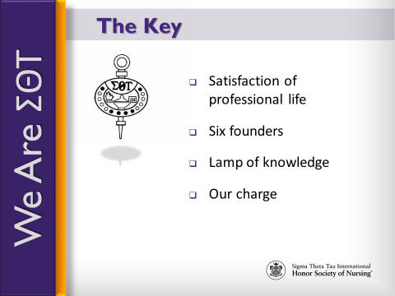 | Our key, embedded in the membership pin, reminds us of our charge to uphold love, courage, and honor and is a symbol of scholarship.  - The cup denotes the satisfaction of professional life;  - The circle with its six stars or six purple stones represents our six founders;  - The lamp is the lamp of knowledge; and  - The letters in black represent our charge.  Remember that our key symbolizes your commitment to nursing excellence.
10 | 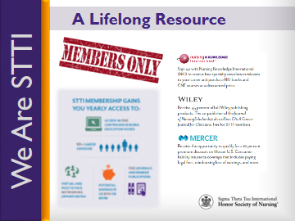 | The purpose of this ceremony is not only to honor you as a new member and celebrate your successes, but it also serves as our pledge to you to support you throughout your nursing career and to be a lifelong resource for you.  This support will come, in part, through the opportunity to participate in STTI’s communities of interest, mentoring programs, and academies. You will also have access to benefits such as continuing nursing education courses, the Journal of Nursing Scholarship, Worldviews on Evidence-Based Nursing, and Reflections of Nursing Leadership.
11 | 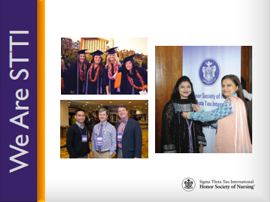 | Your induction is not the end – the culmination of your scholarly or professional achievements; instead, your induction signifies the beginning of your membership journey – the start of your involvement within a global network of peers and mentors who are here to guide and support you wherever your nursing career may take you.
12 | 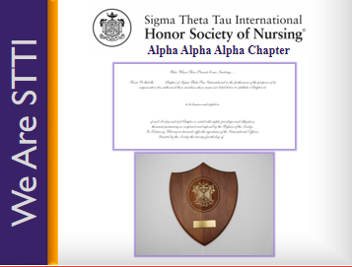 | [Presentation and Response]  Chartering Officer:  Your nursing honor society at ________ [college/university name] has demonstrated its commitment to nursing excellence, met the requirements for establishing a chapter, and was approved to become an STTI Chapter.  Will the following nursing honor society representatives please come forward:  (name), honor society president  (name), honor society (officer position)  As representatives of your nursing honor society, do you know and accept the purposes of the Honor Society of Nursing, Sigma Theta Tau International?  Chapter Representative:  Yes, we the members of this nursing honor society have studied the purposes of the Honor Society of Nursing, Sigma Theta Tau International, and we accept them as the model for our own endeavors.  Chartering Officer:  On the recommendation of the Honor Society of Nursing, Sigma Theta Tau International Board of Directors, and by the power vested in me as the chartering officer, I am pleased to announce your chapter will be known as [Greek name] Chapter, chapter number [chapter number] of the Honor Society.  [Pause for applause]  First, I present to you a replica of the top portion of the charter. Following this ceremony, your chapter will receive its official charter with charter members’ names inscribed.  Second, I present your chapter’s coat-of-arms plaque, which symbolizes the ideals of STTI and is inscribed with your chapter’s name and chartering date. Your chapter may choose to display the charter and coat-of-arms as a symbol of its continued commitment to nursing excellence and the honor society’s purposes.  Chapter President:  On behalf of the prospective members, I am honored to accept this charter and coat-of-arms plaque for the [Greek name] Chapter at College/University. We are proud to become a chapter and pledge our commitment to nursing excellence and STTI’s purposes.  [Pause for applause]  [Representatives may return to their seats]  [Congratulations]  Chartering Officer:  Will [name], [position title—dean or director], please come forward and recognize those persons wishing to congratulate the Chapter for receipt of its charter and coat-of-arms.  [Dean/Director should present a congratulations message from the nursing school or college/university. Dean/Director should also allow brief congratulatory messages from others. Dean/Director should then return to his/her seat.]  Chartering Officer:  Thank you, [dean/director’s name]. Please join me in congratulating this new chapter of the Honor Society of Nursing, Sigma Theta Tau International.  [Pause for applause]
13 | 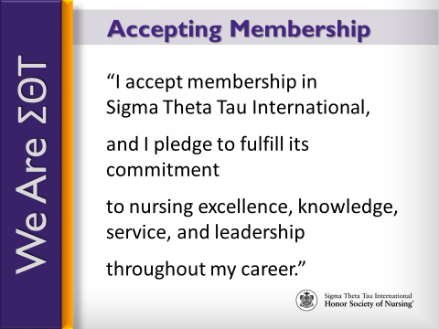 | At this time, we will receive into membership our outstanding new members. Inductees, please stand.  [Pause]  Please accept the privileges and responsibilities of membership in the Honor Society of Nursing, Sigma Theta Tau International by repeating after me.  I accept membership in Sigma Theta Tau International [pause]  and I pledge to fulfill its commitment [pause]  to nursing excellence, knowledge, service, and leadership [pause]  throughout my career.  Inductees, please be seated.
14 | 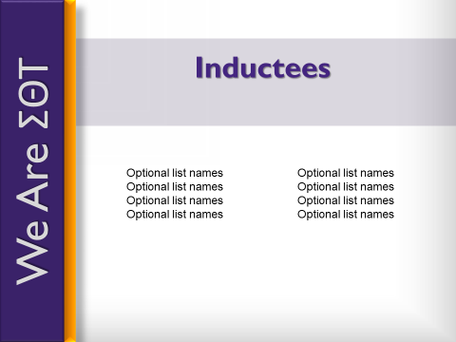 | [Optional: If you have any officers, deans, or heads of school that have never been inducted into STTI before and will be inducted at the ceremony, you should induct them first. If the President has not been inducted, the chartering officer should lead the process of presenting the membership certificate, pin, and honor cord (optional) to the officers. If the President has been inducted into STTI before, the President and chartering officer can do this together. After those officers are inducted, they will remain on stage to present induction materials to the rest of the inductees. Use this script and slide to conduct this portion. If all chapter leaders have been inducted into STTI, delete this portion]  Chapter President (if not being inducted. If President is being inducted, Chartering Officer will read this):  We will first induct our officers who are new STTI members. Officers, please come forward to receive your certificate and sign your name in the membership record.  _________________(name) ______________(title)  _________________(name) ______________(title)  _________________(name) ______________(title)  [repeat as needed]
15 |  | [Chartering officer should now join other chapter leaders on the stage, if not already, to shake hands with each new inductees as they come on stage to receive their new member materials. Only those nurses who are new members to STTI will receive a membership card, certificate and materials.]  Chapter President:  Helping us congratulate and recognize __________________ [chapter’s name] new members are: [introduce people on stage]  _________________ (name) ____________________ (title)  _________________ (name) ____________________ (title)  _________________ (name) ____________________ (title)  _________________ (name) _____________________ (title)  New members, please come forward when your name is called to receive your certificate and sign your name in the [Chapter Name] record of membership.  [Insert candidates’ names here]  [President will call each candidate forward.  In a line:  - The chartering officer will present certificate to and shake hands with each candidate.  - Chapter officers will:  - Pin purple ribbons on candidates  - Distribute other membership materials  - Distribute flowers (optional)  - Assist with the Signature Book]
16 | 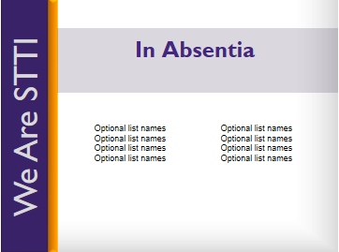 | Chapter President:  We would also like to recognize our new members who were unable to attend today’s ceremony. We welcome them as well and hope they can join us at our next gathering.
17 | 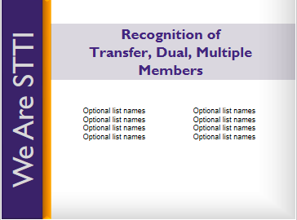 | Chapter President:  I would like to take a moment to recognize STTI members who have transferred to this new chapter or have become a dual or multiple member. Along with our newly inducted, these members will also be considered chartering members of ______ (name of chapter). Please stand and be recognized.
18 |  | Chartering Officer:  Please help me congratulate these new Sigma Theta Tau International members with our applause.  [Presider leads applause]  Now that you are official members of STTI, the opportunities to become involved, to grow and develop as leaders, and to contribute to the nursing profession are virtually endless. Personally, I have enjoyed being actively involved by [chartering officer will insert personal testimonial].
19 | 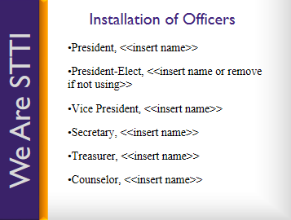 | Chartering Officer:  Leading you as members of the Chapter at the local level will be an elected group of officers. The following persons have been appointed or elected as the first group of officers for this chapter. As your names are called, please come forward:  President  President-Elect (optional)  Vice President  Secretary  Treasurer  Counselor  As set forth in the chapter’s bylaws, the duties of the officers are as follow:  - The president, as executive officer, administers all business of the chapter and serves as chief representative of the chapter at inter-chapter activities and as an ex-officio member of all committees except the Leadership Succession Committee.  - The president-elect assists the president in providing leadership for this chapter and succeeds into the presidency. [delete from slide and script if no president-elect]  - The vice president performs the duties of the president in the president’s absence.  - The secretary prepares and distributes meeting minutes and correspondence.  - The treasurer is the custodian of the chapter’s funds and proposes a budget to the board of directors.  - The counselor oversees the membership eligibility process.  If your duties are fully understood, please answer “yes.”  [Chapter officers answer “yes”]
20 | 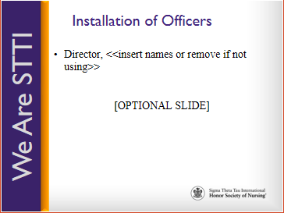 | <<The chapter may or may not have individuals elected as directors. If there are no elected directors, delete slide 18>>  Will the member (s) elected as director(s) please come forward.  Director  Director  The director(s) facilitates the goals and purposes of the chapter through service on the board of directors.  If your duties are fully understood, please answer “yes.”  [Director(s) answers “yes”]
21 | 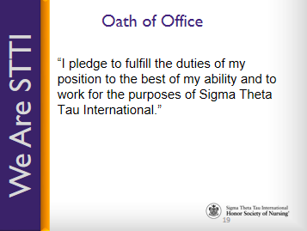 | Will the board of directors (officers and directors) please repeat after me, in unison:  I pledge to fulfill the duties of my position  [pause]  to the best of my ability  [pause]  and to work for the purposes of Sigma Theta Tau International  [pause]  I now recognize , president of Chapter.
22 | 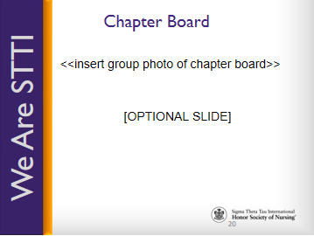 | Chapter President:  We, the board of directors, appreciate the confidence our members have placed in us, and we realize we have an obligation to serve the interests of our membership, our chapter, and the honor society. We look forward to our work in promoting nursing excellence and the honor society’s purposes.  [Pause for applause]  [Board of directors may return to their seats]
23 |  | Chartering Officer:  Each of you will experience membership in your own way. In fact, STTI membership is an experience that is yours to design. I hope you will make use of the many opportunities that membership has to offer. Not only do you have the opportunity to be involved locally, but there are opportunities to participate in this global organization on a regional and international level as well.
24 | 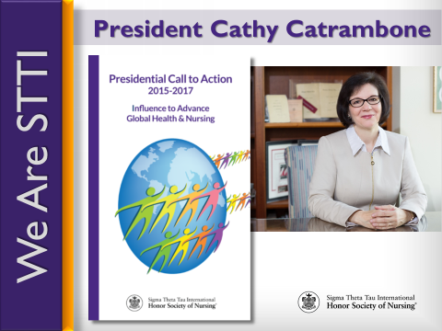 | Each biennium, STTI installs a new president at the international level. This biennium, we proudly installed Dr. Cathy Catrambone and introduced her as the 30th president of Sigma Theta Tau International.  Each president presents a Call to Action to help guide members and chapters as we strive to fulfill our mission. President Catrambone’s call asks us to Influence Advance Global Health and Nursing through advocacy, policy, lifelong learning, and philanthropy.
25 |  | Advocacy is the act or process of pleading for, supporting, or recommending a cause or course of action. Advocacy is a central element in nursing and midwifery. From the moment we enter the profession, we advocate for patients; we “give voice” to what is needed to promote the safety and well-being of those we serve. We advocate for individuals, communities, and populations. We advocate for rights, causes, and issues. We possess the knowledge, skills, relationships, and the passion to be effective advocates. Now is the time to embrace advocacy, to amplify our voice, to bring together stakeholders, and to exert influence to achieve the changes needed in healthcare.
26 |  | We are also called upon to bring together communities and stakeholders to collaborate on policy discussion and action. We bring credibility to the message and influence decision makers. We are challenged to influence and advance in policy in the areas where we live and practice. Embrace opportunities to create, influence, evaluate, and change health policy within your practice environment, professional organizations, health associations, and community. Develop relationships with local legislators, ministers of health, and administrators. Leverage professional networks and social media to share important changes being made in the policy arena.
27 | 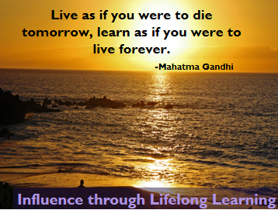 | Advance through lifelong learning. This charge urges each of us to engage in lifelong learning by pursuing advanced education and certifications, and by taking advantage of STTI knowledge products and services.
28 |  | The last charge presented to us is one of philanthropy, which means giving of your time and talent in addition to monetary support. Consider performing 90 minutes of service in honor of STTI Founders Day on 5 October each year. Volunteer. Support STTI’s Future, Leadership, and Research funds, and advocate for the STTI mission.  I would encourage you all to learn more and participate in fulfilling President Catrambone’s Call to Action by visiting STTI’s website, nursingsociety.org.
29 |  | I want to take a moment to recognize and thank the friends and family who are here to celebrate this special occasion with us. It is because of your love and support that these new members were able to reach this level of success, and you should take pride in the role you have played.
30 |  | As we conclude our ceremony, I want to once again congratulate and welcome our newest members of Sigma Theta Tau International.  [Lead applause]
31 |  | Optional Slide  [If the group is having a reception, dinner, or refreshments after the ceremony, include information here]

